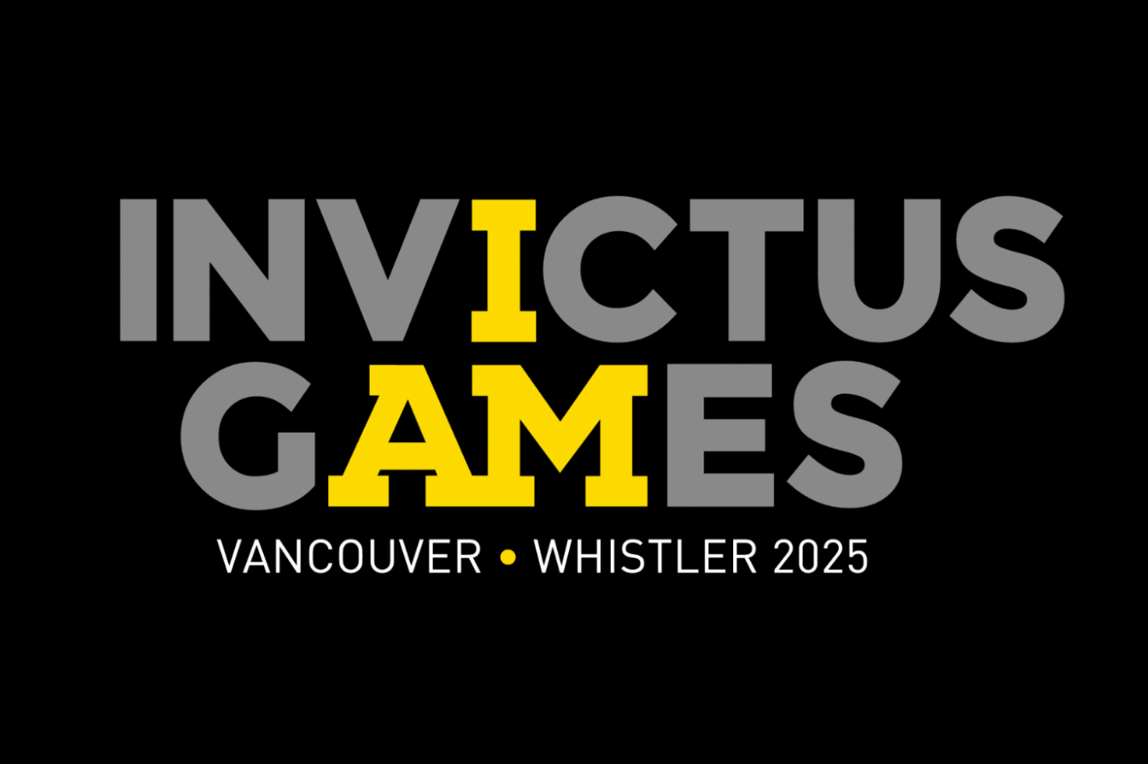
True Patriot Love CIMVHR Research Initiative IG2025 – Call for Proposals – Application Template

PROJECT OVERVIEW
Project title:

Focus area / keywords:
Principal Investigator (PI): The PI must be a researcher affiliated with a Canadian CIMVHR University Member.

Name:
Position:
Institution (Department):
Mailing Address:
E-mail Address:
Phone Number:
International Partner –Co-Investigator: Due to the international nature of the Invictus Games, Canadian PI’s are encouraged to build multi-disciplinary teams inclusive of researchers from IG Participating Nations. This list of participating nations from the last IG 2023 in Dusseldorf, Germany will act as a guide until this year’s PN’s are confirmed. (find list here)

Name:
Position:
Institution (Department):
Mailing Address:
E-mail Address:
Phone Number:
Opportunities for Highly Qualified Personnel (HQP) training and development

Please indicate your need for the following:
Post-doctoral fellow (for a max. 2-year term): ______
PhD student (for a max. 2-year term): ______
Master’s student: ______
Undergraduate / college student: ______

Please describe precisely how the proposed research project will develop HQP and the skills of trainees:

Lay Summary
The lay summary should not be longer than 250 words describing the nature of the work to be done. It should be written in clear, plain language. It should be written in non-technical terms that can be clearly understood by reviewers/readers with various areas of expertise (i.e., minimal academic terminology and references to methodology). Indicate why and to whom the research is important, the anticipated outcomes, and how your field and Canada military, Veterans and/or their families will benefit. Describe the specific challenges, research problems, or complexities that this project expects to address. What are the barriers that need to be overcome?

COLLABORATORS
Academic partner(s) if applicable (i.e., other university institutions and/or research hospitals) – if additional partners, please duplicate this box and add content

Contact name and title:
Organization:
Mailing address:
E-mail address:
Phone number:
Role on project:
Government partner(s) if applicable (i.e., other university institutions and/or research hospitals) – if additional partners, please duplicate this box and add content

Contact name and title:
Organization:
Mailing address:
E-mail address:
Phone number:
Role on project:
Commercial partner(s) if applicable (i.e., other university institutions and/or research hospitals) – if additional partners, please duplicate this box and add content

Contact name and title:
Organization:
Mailing address:
E-mail address:
Phone number:
Role on project:
RELEVANT EXPERIENCE
Please describe the expertise and relevant experience of the principal investigator and co-investigator(s) (if applicable) in successfully completing the work described herein (e.g., publication history):

FUNDING / FUNDING COLLABORATORS
Does the project have existing funding Yes / No

If YES, please provide an understanding of the nature of the existing funding and advise of any funding collaborators:
RESEARCH PROPOSAL DETAILS
Objectives of the proposed research project:
These must be in line with the IG2025 Legacy Research Project’s vision and priorities as presented by True Patriot Love and CIMVHR.

Research question(s) and/or hypothesis(es):

Methodology (including timelines) and why it was chosen:

Plans for collaboration (if applicable), including a rationale of why the proposed partners were chosen:
Include collaboration plans across academic and government partners.

Approximate budget to be presented in CAD dollars (including rationale):
(Note: indirect costs of research will not be funded through this initiative. Funder is a Not-For-Profit entity.)

Key dependencies / risks:
Does your project have any key dependencies without which it would not be able to proceed? Outline any risks and mitigation strategies.

Contribution that the research will make to the advancement of knowledge:
Plans to disseminate findings and/or enhance the potential for impact, including capacity building (e.g., training, education, skills development):
References

PROJECT PLAN
Project plan:
Please provide a project work plan and schedule of activities / proposed deliverables in the table below that identifies milestones at 1-month intervals. The activity schedule will be used to assess whether a project is feasible and whether the available resources are adequate to complete it on schedule. Please note that fostering skills development of HQP and knowledge translation across academic and government partners is integral to CIMVHR’s mandate. A key determinant for a successful CIMVHR application is the ability to adequately define intended research outcomes.
Please include project milestones and the activities/steps required to achieve them; the start and end dates for the activities leading to the milestones; and the major results or key deliverables expected.

Estimated Duration:
Project start date: ______________
Project end date: ______________

Expected Project Duration:
Project Activities / Deliverables  (insert more rows if needed) | Expected Outcome | Start Date | End Date

RESEARCH IMPACT
Disseminating research results through knowledge translation activities is a priority of this initiative. In 500 words or less, describe the anticipated impact of the aforementioned research, with particular emphasis on how it will be communicated to broader stakeholder groups (e.g., academia, government, clinicians, practitioners, and end-users).

